**Emergency Information on Mobile**

Project Plan

By

Putchakarn Jaikon 542115031

Sawatdiporn Kitirot 542115065

Department of Software Engineering

College of Arts, Media and Technology

Chiang Mai University

Project Advisor

__________________________________

**Aj.Chartchai Doungsa-ard**

**Document History**

|  |  |  |  |  |  |  |
| --- | --- | --- | --- | --- | --- | --- |
| **Document Name** | **Version** | **Status** | **Date** | **Viewable** | **Editable** | **Responsible** |
| **Documents** | | | | | | |
| **EIOM-ProjectPlan-V.1.0.docx** | •    Introduction | Draft | 31/5/2013 |  |  |  |
| •    Infrastructure | Putchakarn | Putchakarn | Putchakarn |
| •    Management Procedures | Sawatdiporn | Sawatdiporn | Sawatdiporn |
| •    Quality Standard | Aj.ChartChai |  |  |
| •    Quality Planning |  |  |  |

Table of Content

Chapter One | Introduction 4

1.1 Identification 4

1.2 Project Overview 4

1.3 Document Overview 4

1.4 Work Products to be Develop 5

1.5 Acronyms and Definitions 5

Chapter Two | Infrastructure 7

2.1 Software Development Life Cycle 7

2.2 Software Acquisition Plans 8

2.3 Hardware and Material Resources 8

Chapter Three | Management Procedures 9

3.1 Project Team Structure 9

3.2 Monitoring and Controlling Mechanism 9

3.2.1 Project Meeting 9

Chapter Four | Quality Plan 10

4.1 Quality Factors 10

4.2 Reviews/Responsibility 11

4.3 Testing 11

4.4 Software Development Standard 11

Chapter Five | Estimated Duration of Tasks 14

Chapter Six | Estimated Effort and Cost 16

Chapter Seven | Identification of Project Risks4.4 17

7.1 Risk Identification and Solutions 17

Chapter Eight | Version Control Strategy 18

8.1 Naming Conversion 18

8.2 Project Repository 19

8.3 Configuration Item Table 20

# Chapter One | Introduction

## Identification

The Project Management Plan is the document for planning, scheduling activities and evaluating overall of the project so that the project will complete as successfully as possible in spite of all the risks. The Project Management will lead us to see specific project reach fruition and allow us to work with it and see a project through from start to finish.

## Project Overview

Emergency Information on Mobile provides user application and admin webpage. The application will show online map and offline map. User can views the information of each help place on the map and call directly from the application. The admin webpage uses to manage the information such as add, edit information and delete help place out of the database.

* + 1. **Purpose & Scope**

Emergency Information on Mobile will support online map and offline map to help people about the information of the help pace. The application will provide the offline map with information around the user when they lost Internet connection.

## Document Overview

The purpose of the Emergency Information on Mobile project plan is to guide project team members during the development of Emergency Information on Mobile project.

**Progress Report I** consist of

**• Feature 5: Manage Information System**

[URS-01]: The administrator can add help information, which includes name, address, district, province, zip code, phone number, category, latitude and longitude.

[URS-02]: The administrator can edit help information, which includes name, address, district, province, zip code, phone number, category, latitude and longitude.

[URS-03]: The administrator can remove help location.

[URS-04]: The admin can view help information of each help place.

[URS-05]: The administrator can browse the help location by help place category.

[URS-06]: The administrator can browse the help location by province of Thailand.

[URS-07]: The administrator can browse the help location by category and province of Thailand.

**• Feature 1: Map and Help Information System**

[URS-08]: The user can view the online map with their current location.

[URS-09]: The user can view the offline map with their current location.

[URS-10]: The user can view the help places in online map.

[URS-11]: The user can view the help places in offline map.

[URS-12]: The user can view help information of each help place in online map.

[URS-13]: The user can view help information of each help place in offline map.

[URS-14]: The user can make emergency call to each help place in online map.

[URS-15]: The user can make emergency call to each help place in offline map.

## Work Products to be Develop

|  |  |  |  |  |
| --- | --- | --- | --- | --- |
| **No.** | **Deliverables/Release** | **Media** | **No. of Copies** | **Date** |
| 1 | **Project Proposal**  • Emergency Information On Mobile  Version 1.0 | Document | 3 | 5th March 2014 |
| 2 | **Progress Report I**  • Project Management Plan Version 1.0  • Software Requirement Specification  Version 1.0  • Software Design Document Version 1.0  • Test Plan Version 1.0  • Traceability Record Version 1.0  • Software Version 1.0 | Document | 3 | 28th May 2014 |

**1.3.1Deliverable**

## Acronyms and Definitions

**1.5.1 Acronyms**

EIOM Emergency Information on Mobile

SRS Software Requirement Specification

URS User Requirement Specification

**1.5.2 Definition**

|  |  |
| --- | --- |
| Acceptance Test | Test activities for sample checks to verify that a system (or product, solution) has the right quality for development or usage. Often acceptance test is done by the customer. [IEEE90] |
| Feature | Transformation of input parameters to output parameters based on a specified algorithm. It describes the functionality of a product. Used for requirements analysis, design, coding, testing or maintenance. [IEEE90] |
| IEEE | Institute for Electrical and Electronics Engineers. Biggest global interest group for engineers of different branches and for computer scientists. [IEEE90] |
| Plan | A documented series of tasks requires meeting an objective, typically including the associated schedule, budget, resources, organizational description and work breakdown structure. [IEEE90] |
| Project Management | The application of knowledge, skills, tools, and techniques to project activities in order to meet or exceed stakeholder needs and expectations from a project. [IEEE90] |
| Project plan | A formal, approved document used to guide both project execution and project control. The primary uses of project plan are to document planning assumptions and the decision, to facilitate communication among stakeholders, and to document approved scope, cost, and schedule baseline. [IEEE90] |
| Risk | An uncertain event or condition that, if it occurs, has a positive or negative effect on a project's objectives. It is a function of a probability of occurrence of a given threat's occurrence. [IEEE90] |
| Risk Management | The systematic application of management policies, procedures and practices to the tasks of identifying, analyzing, evaluating, treating and monitoring risk. [IEEE90] |
| Traceability | The ability to trace the history, application or location of an item or activity, or work products or activities, by means of recorded identification. The establishment and maintenance of relationships between such items. Horizontal traceability describes the relationship between work products of same type (e.g., customer requirements). Vertical traceability describes the relationship between work products which build upon each other or are derived from each other (e.g., from customer requirements to qualification test cases). Bidirectional traceability allows to directly following relationships in both directions. [IEEE90] |
| Unit test | A test of individual programs or modules in order to remove a design or programming errors. [IEEE90] |

# Chapter Two | Infrastructure

## 2.1 Software Development Life Cycle

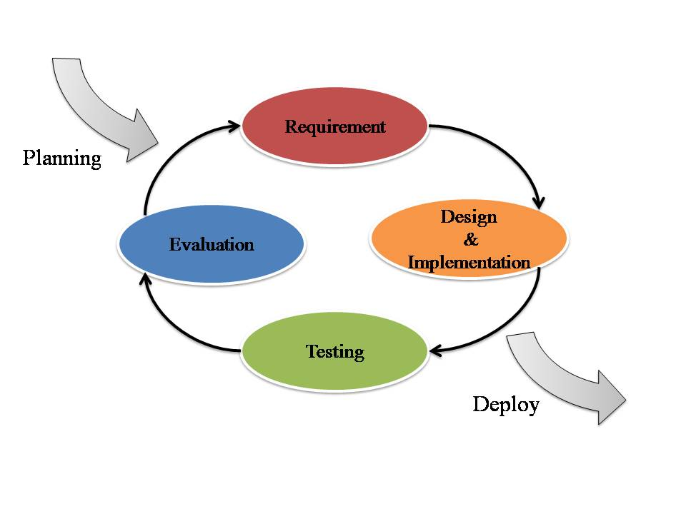

**Figure 1 Iterative Development Model**

Figure 1 presents a method of software development. Iterative development model is a cyclic software development process developed in response to the weaknesses of the Waterfall model. The model starts with planning and continues through iterative development cycles.

Emergency Information on Mobile use Iterative Development Model. Developer can use model to develop the iterative way to fulfill, change software and document for each development process.

## 2.2 Software Acquisition Plans

**2.2.1 Design Tools**

* Photoshop CS6
* Adobe Dreamweaver CS6

**2.2.2 Development Tools**

* Eclipse Kepler
* IntelliJ 12.1.6

**2.2.3 Configuration Management Tools**

* GitHub

**2.2.4 Document Tools**

* Microsoft Word 2013

**2.2.5 Testing Tools**

* Smart Phone Samsung (Android Device)
* Notebook with Google chrome or Firefox browser
* Host Server

## Hardware and Material Resources

* **Internet**
* **Computers**
  + Apple Macbook Pro mid 2013
    - Processor: Intel® Core™ i7-3520M CPU @ 2.90GHz 2.90GHz
    - RAM: 8.00 GB
    - Operating System: Windows 7 Ultimate
  + Dell Inspiron n5110
    - Processor: Intel® Core™ i5-2410M CPU @ 2.30GHz 2.30GHz
    - RAM: 4.00 GB
    - Operating System: Windows 7 Ultimate
* **Mobile phones:** Android Operating System
  + Samsung Galaxy Grand 2 SM-G7102
    - CPU: Quad-core 1.2 GHz Cortex-A7
    - RAM: 1.5 GB
    - Operating System: Android OS, v4.3 (Jelly Bean)
  + Samsung Galaxy S DUOS
    - CPU: 1GHz Cortex-A5
    - RAM: 768 MB
    - Operating System: Android OS, v4.04 (Ice Cream Sandwich)

# Chapter Three | Management Procedures

## 3.1 Project Team Structure

|  |  |
| --- | --- |
| **Roles** | **Responsibility** |
| **Developer** | •         Create document |
|  | - Proposal |
|  | - Project Plan |
|  | - SRS |
|  | - Software Design Document |
|  | •         Develop software |
| **Tester** | •         Create document |
|  | - Test Plan |
|  | - Test Record |
|  | - Traceability Record |
|  | •         Test software |
| **Reviewer** | •         Review document and software |
|  | •         Manage change |

|  |  |
| --- | --- |
| **Participants** | **Roles** |
| Putchakarn Jaikon | Developer, Tester and Reviewer |
| and |
| Sawatdiporn Kitirot |

## 3.2 Monitoring and Controlling Mechanism

### 3.2.1 Project Meeting

|  |  |
| --- | --- |
| **Participants** | **Roles** |
| Aj.Chartchai Doungsa-ard | Project Advisor |
| Putchakarn Jaikon | Development team member |
| Sawatdiporn Kitirot | Development team member |

# Chapter Four | Quality Plan

## 4.1 Quality Factors

**Product operation factors**

* **Correctness**
* The software product should able to provide more than 80% correctness of data from user traditional request.
* **Reliability**
* The software should able to handle more than 80% of traditional activity with less than 10% of software’s failure.
* **Usability**
* The people who use software product, as his first time should be able to estimate complacency of the product more than 70 %

**Product revision factors**

* **Testability** 
  + - The software should able to be tested 100% of it defined routine and functionality.

**Product transition factors**

* **Reusability** 
  + - More than 20% part of finished software product should able to be reused in future development.

## 4.2 Reviews/Responsibility

|  |  |  |  |
| --- | --- | --- | --- |
| **Stage Exit Review** | | | |
| **No.** | **Stage** | **Review Item** | **Responsibility** |
| 1 | The progress report 1 | Project Plan | Putchakarn, Sawatdiporn |
| 2 | The progress report 1 | Requirement Specification | Putchakarn, Sawatdiporn |
| 3 | The progress report 1 | Architecture and Software Design Document | Putchakarn, Sawatdiporn |
| 4 | The progress report 1 | Software Testing | Putchakarn, Sawatdiporn |
| 5 | The progress report 1 | Traceability Record | Putchakarn, Sawatdiporn |

## 4.3 Testing

|  |  |  |
| --- | --- | --- |
| **Test Process** | | |
| **No.** | **Test** | **Responsibility** |
| 1 | Unit Testing | Putchakarn, Sawatdiporn |
| 2 | System Testing | Putchakarn, Sawatdiporn |
| 3 | Acceptance Testing | Putchakarn, Sawatdiporn |

## 

## 4.4 Software Development Standard

**4.4.1 ISO29110 for Very Small Entity (VSE)**

ISO 29110 is a guide applies to Very Small Entities (VSEs), enterprise, organization, department or project up to 25 people, dedicated to software development. The Guide provides Project Management and Software Implementation process which integrate practices based on the selection of ISO/IEC12207- Systems and Software Engineering –Software Life Cycle process – guidelines for the content of software life cycle process information products (documentation) standards elements.

1. **Project Management (PM) process** 
   * **PM purpose**

The purpose of the Project Management process is to establish and carry out in a systematic way the tasks of the software implementation project, which allows complying with the project’s objectives in the expected quality, time and costs.

* + **PM objectives**

**PM.O1:** The *Project Plan* for the execution of the project is developed according to the *Statement of Work* and validated with the Customer. The tasks and resources necessary to complete the work are sized and estimated

**PM.O2:** Progress of the project is monitored against the *Project Plan* and recorded in the *Progress Status Record.* Corrections to remediate problems and deviations from the plan are taken when project targets are not achieved. Appropriate treatment is taken to correct or avoid the impact of risk. Closure of the project is performed to get the Customer acceptance documented in the *Acceptance Record*.

**PM.O3:** The *Change Requests* are addressed through their reception and analysis. Changes to software requirements are evaluated for cost, schedule and technical impact.

**PM.O4:** Review meetings with the Work Team and the Customer are held. Agreements are registered and tracked.

**PM.O5:** *Risks* are identified as they develop and during the conduct of the project.

**PM.O6:** A software *Version Control Strategy* is developed. Items of *Software Configuration* are identified, defined and base lined. Modifications and releases of the items are controlled and made available to the Customer and Work Team including the storage, handling and delivery of the items.

**PM.O7:** Software Quality Assurance is performed to provide assurance that work products and processes comply with the *Project Plan* and *Requirements Specification*

* + **PM Activities**

The Project Management Process has the following activities:

* + - PM.1 Project Planning
    - PM.2 Project Plan Execution
* PM.3 Project Assessment and Control
* PM.4 Project Closure

**2. Software Implementation (SI) process**

* + **SI purpose**

The purpose of the Software Implementation process is the systematic performance of the analysis, design, construction, integration and tests activities for new or modified software products according to the specified requirements.

* + **SI objectives**

**SI.O1:** Tasks of the activities are performed through the accomplishment of the current *Project Plan*.

**SI.O2:** Software requirements are defined, analyzed for correctness and testability, approved by the Customer, base lined and communicated.

**SI.O3:** Software architectural and detailed design is developed and base lined. It describes the software items and internal and external interfaces of them. Consistency and traceability to software requirements are established.

**SI.O4:** Software components defined by the design are produced. Unit test are defined and performed to verify the consistency with requirements and the design. Traceability to the requirements and design are established.

**SI.O5:** *Software* is produced performing integration of software components and verified using *Test Cases and Test Procedures*. Results are recorded at the *Test Report*. Defects are corrected and consistency and traceability to *Software Design* are established.

**SI.O6:** A *Software Configuration* that meets the Requirements Specification as agreed to with the Customer, which includes user, operation and maintenance documentations, is integrated, base lined and stored at the *Project Repository*. Needs for changes to the *Software Configuration* are detected and related *Change Requests* are initiated.

**SI.O7:** Verification and Validation tasks of all required work products are performed using the defined criteria to achieve consistency among output and input products in each activity. Defects are identified, and corrected; records are stored in the *Verification/Validation Results*.

* + **SI activities**

The Software Implementation Process has the following activities:

* SI.1 Software Implementation Initiation
* SI.2 Software Requirements Analysis
* SI.3 Software Architectural and Detailed Design
* SI.4 Software Construction
* SI.5 Software Integration and Tests
* SI.6 Product Delivery

# Chapter Five | Estimated Duration of Tasks

- **Server part**

**Feature5: Manage information system**

Estimate time: 15 April 2014 – 13 June 2014

* Add help place
* Edit help place
* Remove help place
* View help place’s information
* Browse the help place by category
* Browse the help place by province
* Browse the help place by province and category

- **Mobile part**

**Feature1: Map and help information system**

Estimate time: 15 April 2014 – 13 June 2014

* View the online map
* View the offline map
* View the help places in online map
* View the help places in offline map
* View information of each help place in online map
* View information of each help place in offline map
* Make emergency call to each help place in online map
* Make emergency call to each help place in offline map

**Progress I**

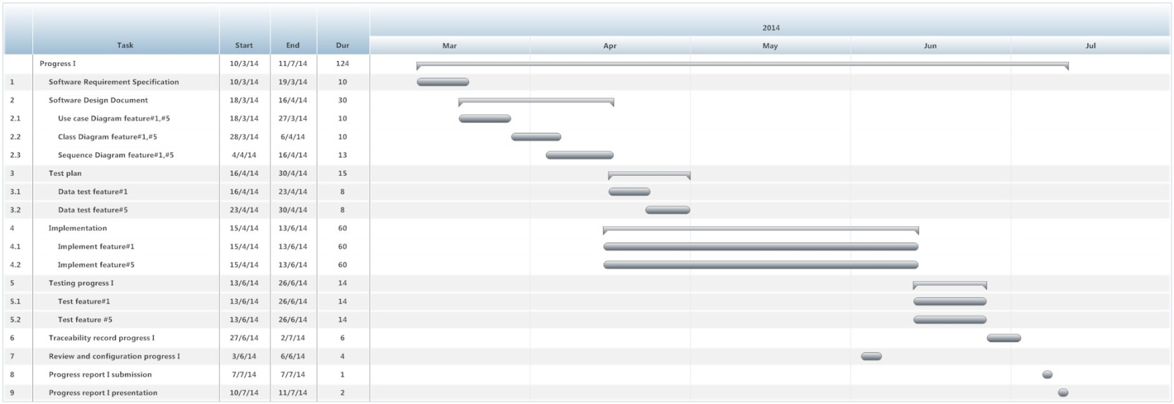

**Figure 2 Milestone of Progress Report I**

Figure 2 shows estimated duration of tasks in the progress report

# Chapter Six | Estimated Effort and Cost

|  |  |
| --- | --- |
| **Item** | **Approximately Cost (THB)** |
| Android Programming textbook | 1,000 |
| Print cost of software document (ink and paper) | 2,000 |
| Printer | 1,500 |

Emergency Information on Mobile application is supported by College of Arts, Media and Technology, Chiang Mai University as a senior project. The faculty will provide 500 THB for poster presentation, and will provide hardware for development.

# Chapter Seven | Identification of Project Risks4.4

# **7.1 Risk Identification and Solutions**

|  |  |
| --- | --- |
| **Risk** | **Solution** |
| Group members lack skill and knowledge. | - Need studying and training time for group members.  - Discuss with people who have knowledge about topic which is required for development. |
| Deal with changes | - Discuss with advisor.  - Use traceability record to control change.  - Use software configuration management and follow changes management step. |
| Group members cannot work in critical time | - Group members should be follow the schedule and milestone to finish work before the due date. |
| Cannot finish project follow the schedule | - Start project before schedule and take more effort to do project such as spend more hours |
| Group members confuse about the version of the document | - Use version control to identify the version of all documents. |
| Computer crash and document has been lost from developer’s computer. | - Need to use the version control version software like, GitHub to store the document |
| Unfamiliar with testing Process | - Study testing technique during the test design.  - Discuss with advisor and people who have knowledge. |

# Chapter Eight | Version Control Strategy

## 8.1 Naming Conversion

For naming conversion of Emergency Information on Mobile project, the name of document and software will be named as following format:

“[Project Name]-[Document Name]-[Version].[File Type]”

* **Project Name**

This part will be the name of this project that is “EIOM”

* **Document Name**

This part will depend on substance of that file. In each file will has its certain name as following:

* Proposal
* Project Plan & Quality Plan
* Software Requirement Specification (SRS)
* Software Design Document (SDD)
* Coding
* Test Plan
* Test Record
* Traceability Record (TR)
* **Version**

This part is the version of document. Version number will be in the following format:

“V.[Main version].[Sub version]”

* **File Type**

This part is the type of file or the file extension. For example, .docx, .pdf.

## Project Repository

**• GitHub**

GitHub is a tool that can help to manage the version of document and software. Developers can share file or update version of file anytime that they want. Developers have to have their own account of GitHub. Then the developers can create project file and can share it with anyone they want.

For Emergency Information on Mobile project, we will create folders to be the project repository as following:

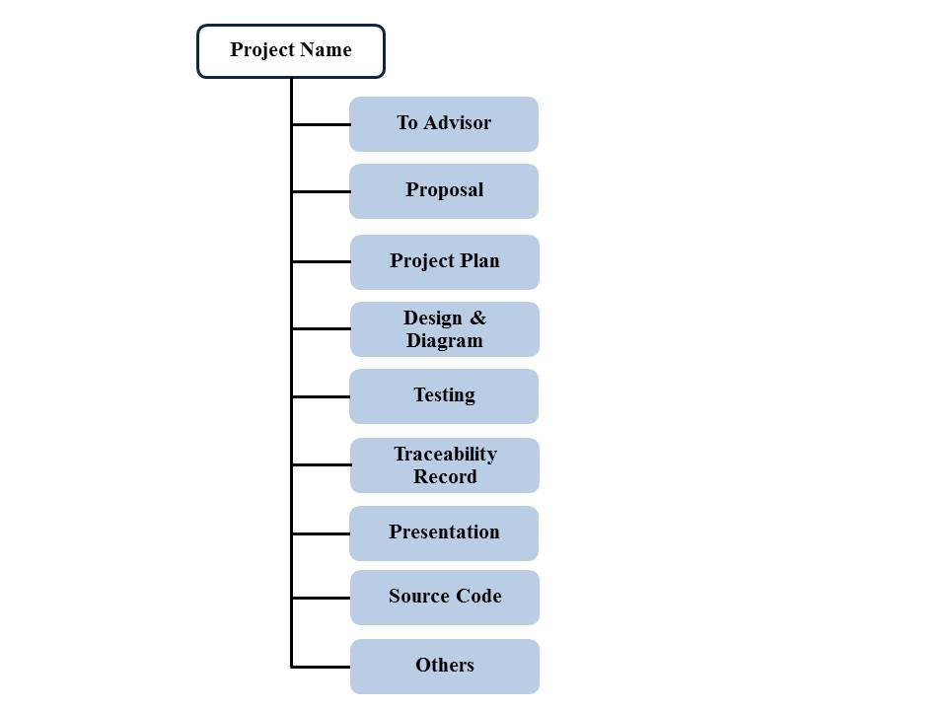

**Figure 3: Repository of Emergency Information on Mobile project**

**List of related document and description**

* To Advisor: contain document files that will be waiting to be reviewed by advisor.
* Proposal: contain involving proposal files.
* Project plan: contain project plan document files.
* Design & Diagram: contain design and diagram document files.
* Testing: contain testing document files.
* Traceability record: contain traceability record document
* Presentation: contain presentation files.
* Source code: contain source code of project.
* Others: contain kind of picture, server information, interesting web site and etc.

## 8.3 Configuration Item Table

|  |  |  |  |  |  |  |
| --- | --- | --- | --- | --- | --- | --- |
| **No.** | **Item** | **File Name** | **File Type** | **Owner** | **Path** | **Baseline** |
| 1 | Project Proposal | EIOM-ProjectProposal-V.1.0 | .docx | Putchakarn, Sawatdiporn | /EIOM /Proposal | 1.0 |
| 2 | Development and Quality Plan | EIOM-Project Plan -V.1.0 | .docx | Putchakarn, Sawatdiporn | /EIOM /Project Plan | 1.0 |
| 3 | Software Requirement Specification | EIOM-SRS-V.1.0 | .docx | Putchakarn, Sawatdiporn | /EIOM /Design&Diagram | 1.0 |
| 4 | Software Design Document | EIOM-SDD-V.1.0 | .docx | Putchakarn, Sawatdiporn | /EIOM /Design&Diagram | 1.0 |
| 5 | Test Plan | EIOM-Test Plan-V.1.0 | .docx | Putchakarn, Sawatdiporn | /EIOM /Testing | 1.0 |
| 6 | Test Record | EIOM-Test Record-V.1.0 | .docx | Putchakarn, Sawatdiporn | /EIOM /Test Record / | 1.0 |
| 7 | Traceability Record | EIOM-Traceability Record-V.1.0 | .docx | Putchakarn, Sawatdiporn | /EIOM / Traceability Record | 1.0 |